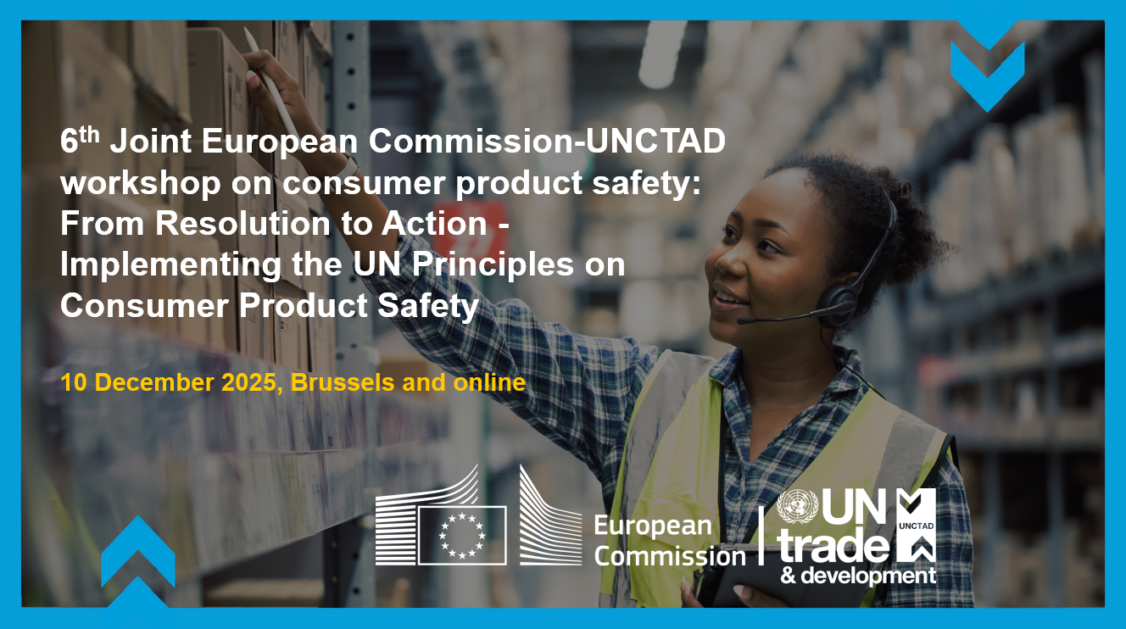

Agenda
10 December 2025
6th EC–UNCTAD Joint Workshop on Consumer Product Safety: From Adoption to Implementation of the UN Principles

13h00 – 13h10 | - Opening Session  Pinuccia Contino, European Commission  Teresa Moreira, UN trade and development (online)
13h10 -13h40 | - Panel Discussion: Implementing the UN Principles  Ms. Quyn Anh Nguyen, Vice Chair of Competition Commission, Viet Nam  Mr. Hardin Ratshisusu, Acting Commissioner of the National Consumer Commission, South Africa  Dr. Willard Mwemba, Chief Executive Officer for the Competition Commission of the Common Market for Eastern and Southern Africa (COMESA)
13h40 -14h10 | - Breakout Discussions  Breakout room 1.  Information to consumers & international cooperation  Moderator: Arnau Izaguerri, Legal Officer, UNCTAD  Breakout room 2.  Regulation, standards & responsibilities of authorities  Moderator: Yvonne Stein, Deputy Director, Consumer Policy Division, Ministry of Finance, Sweden and Marie Gerardy, Legal and Policy Officer, European Commission  Breakout room 3.  Business engagement & multi-stakeholder cooperation  Moderator: Cynthia Zapata, Director of Consumer Protection, Ministry of Economy, Industry and Trade, Costa Rica  Breakout room 4.  Risk identification, assessment & corrective measures  Moderator: Myriam Denieul, Legal and Policy Advisor, European Commission  Breakout room 5.  Engaging new product safety authorities  Moderator: Ana Cipriano, Legal Officer, UNCTAD
14h10 -14h25 | - Report to Plenary
14h25 -14h30 | - Closing Remarks  Pinuccia Contino, European Commission

