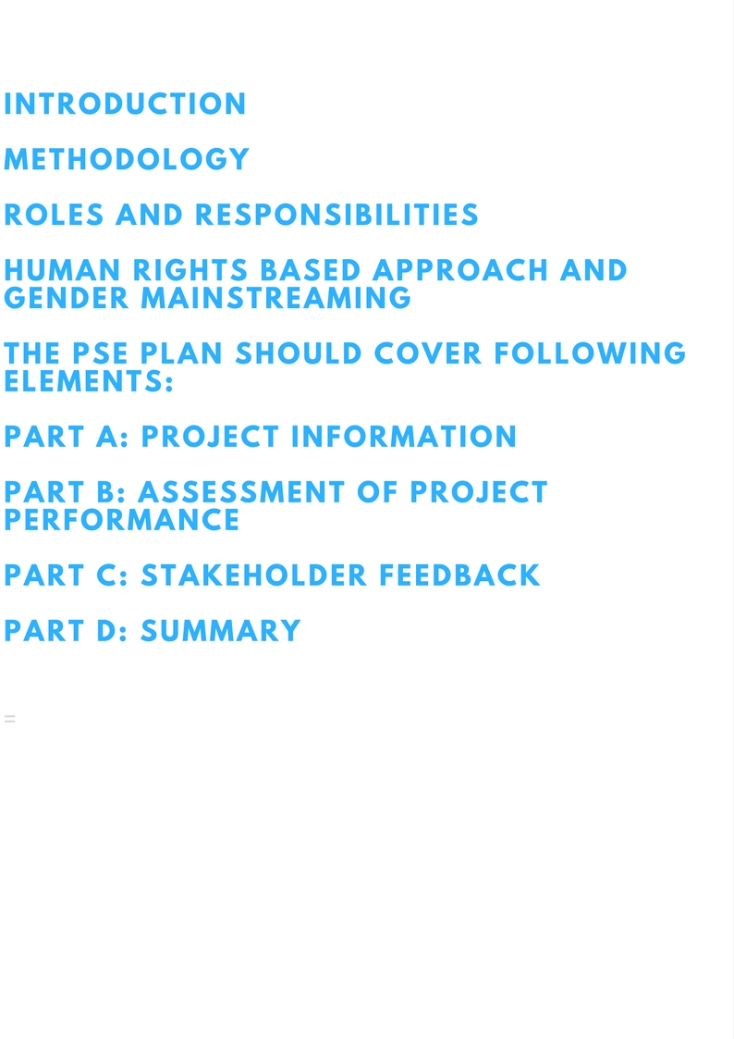

PREPARED BYClick here to enter your name.

DATEDClick here to enter the date.

**1. PROJECT TITLE** Click here to enter the Project Title.

**2. PROJECT NUMBER** Click here to enter the Project Number.

**3. DIVISION/BRANCH** Click here to enter the Division/Branch.

**4. PROJECT OWNER OFFICE** Click here to enter the Project Owner Office.

**5. REGION(S)/COUNTRY(IES)** Click here to enter the Region(s)/County(ies).

**6. PROJECT STARTING DATE** Click here to enter the Project starting date.

**7. PROJECT COMPLETION DATE** Click here to enter the Project completion date.

**8. TOTAL APPROVED PROJECT BUDGET**Click here to enter the total approved budget.

**9. ESTIMATED TOTAL EXPENDITURES** Click here to enter the estimated total expenditures.

**10. BENEFICIARIES** Click here to enter the Project beneficiaries.

**11. DONOR/S** Click here to enter the Project donors.

**12. PARTNERS** Click here to enter the Project partners.

**13. TYPE OF EVALUATION** Choose type of evaluation

*How many project extensions and budget extensions took place? Briefly describe their purpose.*

**Click here to indicate your answer.**

*Explain how coordination between evaluations of the different levels of UNCTAD programming is envisaged to ensure coherence among evaluations.*

**Click here to indicate your answer.**

This section is filled in the following steps:

Step 1: Provide an overall introduction to project;

Step 2: Assess the overall performance for each evaluation criteria through check box answer;

Step 3: Explain your overall performance assessment based on the guiding evaluation questions;

Step 4: Provide recommendations based on your assessment through text box answer.

## 1. INTRODUCTION

*Provide a brief description of the project including: objective of the project interventions; rationale for selected activities; significant changes during implementation in objectives, target groups, components, implementation arrangements, or funding; and the rationale for these changes (if any).*

**Click here to indicate your answer**

*Provide a brief description of the evaluation type, objectives of the evaluation, methodology and any limitations.*

**Click here to indicate your answer**

## 2. RELEVANCE

*2.1 Relevance is defined as the extent to which the objectives of a project are continuously consistent with recipients’ needs, UNCTAD mandate and overarching strategies and policies. How would you assess the relevance of the project?*

Extremely relevant

Relevant

Moderately relevant

Moderately irrelevant

Irrelevant

Highly irrelevant

*2.2 Which specific SDGs did your project contribute to?*

*Main SDGs: Secondary SDGs: Cross-cutting SDGs:*

SDG17 SDG12 SDG1

SDG10 SDG14 SDG5

SDG9 SDG15

SDG8

Which specific targets of the selected main SDGs did your project directly contribute to?

**Click here to indicate your answer**

*2.3 Were project counterparts involved in the design of the project?*

Yes Partially Mostly No

*2.4 Did the project design relate to the objectives, outcomes and/or outputs of a toolbox programme?*

Yes No

*Elaborate on your assessment by utilizing the following guiding questions:*

* *How relevant is the project to other key stakeholders’ (executing agencies, partner organizations, including other UN agencies, NGOs etc.) needs and priorities?*
* *Did the project provide something unique in meeting these needs?*
* *How relevant is the project to the UNCTAD pillars of research and analysis and intergovernmental consensus building?*
* *How is the project in line with the 2030 Agenda and the Nairobi Maafikiano?*
* *Are there any general lessons applicable to UNCTAD that could be drawn as regards to relevance?*

**Click here to indicate your answer**

*Propose a maximum of two recommendations related to relevance in the table below. Resource implications can refer to human, financial or technological resources.*

|  |  |  |  |  |
| --- | --- | --- | --- | --- |
| **Recommendation** | **Specific action** | **Responsible person, within UNCTAD, for follow-up** | **Resource**  **implications** | **Follow-up date** |
| 1. |  |  |  |  |
| 2. |  |  |  |  |
| 3. |  |  |  |  |

## 3. EFFICIENCY

*3.1 Efficiency is defined as a measure of how resources/inputs (funds, expertise, time, etc.) are converted into outputs. How would you assess the efficiency of the project?*

Extremely efficient

Efficient

Moderately efficient

Moderately inefficient

Inefficient

Highly inefficient

*3.2 Were the logical framework’s performance indicators specific, measurable, achievable, realistic and time-bound (SMART)?*

Yes Partially Mostly No

*3.3. Were UNOG/UNCTAD administrative and financial processes adequate to manage the project?*

Yes Partially Mostly No

*Elaborate on your assessment by utilizing the following guiding questions:*

* *To what extent were activities implemented on schedule and within budget?*
* *Were there any developments or problems that required significant adjustments in the project plans?*
* *To what extent were outputs delivered economically?*
* *To what extent has the project been efficient in utilizing the three pillars of UNCTAD (research and analysis, intergovernmental consensus building and technical cooperation) in an integrated manner?*
* *Are there any general lessons applicable to UNCTAD that could be drawn with regards to efficiency?*

**Click here to indicate your answer**

*Propose a maximum of two recommendations related to efficiency in the table below. Resource implications can refer to human, financial or technological.*

|  |  |  |  |  |
| --- | --- | --- | --- | --- |
| **Recommendation** | **Specific action** | **Responsible person, within UNCTAD, for follow-up** | **Resource**  **implications** | **Follow-up date** |
| 1. |  |  |  |  |
| 2. |  |  |  |  |

## 4. EFFECTIVENESS

*4.1 Effectiveness is defined the extent to which the project’s objectives and outcomes were achieved. How would you assess the effectiveness of the project?*

Extremely effective

Effective

Moderately effective

Moderately ineffective

Ineffective

Highly ineffective

*Structure your response by describing the progress against the objectives and outcomes Elaborate on your assessment by utilizing the following guiding questions:*

* *Were the planned objectives and outcomes achieved? Provide a brief and systematic analysis of project progress in achieving planned outcomes and objectives.*
* *What were the main factors affecting the achievement or non-achievement of planned outcomes and objectives?*
* *Are there any results achieved beyond those identified in the logical framework? If yes, explain reasons for variance between planned outcomes and objectives in the logical framework, and actual achieved outcomes and objectives.*
* *How were the research and studies produced by the project utilized?*
* *How did the research and studies produced by the project reach their target audience?*
* *Are there any general lessons applicable to UNCTAD that could be drawn as regards to effectiveness?*

**Click here to indicate your answer**

*Propose a maximum of two recommendations related to effectiveness in the table below. Resource implications can refer to human, financial or technological.*

|  |  |  |  |  |
| --- | --- | --- | --- | --- |
| **Recommendation** | **Specific action** | **Responsible person, within UNCTAD, for follow-up** | **Resource**  **implications** | **Follow-up date** |
| 1. |  |  |  |  |
| 2. |  |  |  |  |
| 3. |  |  |  |  |

## 5. SUSTAINABILITY

*5.1 Sustainability is concerned with measuring whether the benefits of a project are likely to continue after its termination. How would you assess the sustainability of the project?*

Extremely sustainable

Sustainable

Moderately sustainable

Moderately unsustainable

Unsustainable

Highly unsustainable

*5.2 Upon project completion and end of external funding, is stakeholders’ engagement likely to be:*

Discontinued

Continued at the same level

Scaled-up

Replicated/institutionalized

*Elaborate on your assessment by utilizing the following guiding questions:*

* *To what extent are the project results likely to continue for an extended period after the project ends? Differentiate between capacity/ ownership challenges, and influenceable/non-influenceable factors.*
* *Were sustainability considerations built into the project design and implementation stages?*
* *Are there any general lessons applicable to UNCTAD that could be drawn as regards to sustainability?*

**Click here to indicate your answer**

*Propose a maximum of two recommendations related to sustainability in the table below. Resource implications can refer to human, financial or technological.*

|  |  |  |  |  |
| --- | --- | --- | --- | --- |
| **Recommendation** | **Specific action** | **Responsible person, within UNCTAD, for follow-up** | **Resource**  **implications** | **Follow-up date** |
| 1. |  |  |  |  |
| 2. |  |  |  |  |
| 3. |  |  |  |  |

## 6. IMPACT

*6.1 Impact refers to lasting changes—positive and negative, intended and unintended—arising from the intervention. It may take years for these types of changes to become apparent. It is often difficult to attribute the observed changes to a particular intervention alone because other factors and actors may have contributed to the results as well. Thus, achieving the impact is generally beyond the direct control of the intervention. Two important concepts in measuring impact are attribution and contribution. Attribution means that the particular intervention led to the observed outcomes and that it can be attributed to causing the outcome. Contribution means that the intervention helped to cause the observed outcomes, that it was a factor capable of causing the change.*

*Is there any evidence of the project’s interventions contributing or attributable to lasting impact?*

Yes Partially Mostly No N/A

*Elaborate on your assessment by utilizing the following guiding questions:*

* *What lasting changes did the project bring about?*
* *What were the unplanned or unintended changes?*

**Click here to indicate your answer**

*Propose a maximum of two recommendations related to impact in the table below. Resource implications can refer to human, financial or technological.*

|  |  |  |  |  |
| --- | --- | --- | --- | --- |
| **Recommendation** | **Specific action** | **Responsible person, within UNCTAD, for follow-up** | **Resource**  **implications** | **Follow-up date** |
| 1. |  |  |  |  |
| 2. |  |  |  |  |

## 7. CROSS-CUTTING ISSUES: GENDER, HUMAN RIGHTS & ENVIRONMENTAL SUSTAINAILITY

*7.1 While gender equality is a human right, it is also a dimension of development in its own right. Gender and human rights refers to the extent to which the project’s achievements contributed to the improvement of gender equality and human rights (including equity considerations). How would you assess this contribution by the project?*

Extremely satisfactory

Satisfactory

Moderately satisfactory

Moderately unsatisfactory

Unsatisfactory

Highly unsatisfactory

*7.2 Did the project analyze whether women and men will be differently affected by the project in terms of their rights, needs, roles and opportunities?*

Yes Partially Mostly No

*7.3 Did the project contribute to gender equality and women's economic empowerment?*

Yes Partially Mostly No

*7.4 Did the project consider environmental sustainability concerns in its design or implementation?*

Yes Partially Mostly No N/A

*Elaborate on your assessment by utilizing the following guiding questions (if already addressed in the section on relevance above, you can repeat some of the text here):*

* *To what extent did the project’s achievements contribute to the improvement of gender equality and human rights?*
* *Were ministries in charge of gender equality issues, women/gender-focused groups or associations, and women's business associations in the beneficiary countries consulted and involved throughout the project implementation? If not, please provide explanations.*
* *Did the project collect or use gender-disaggregated data in its analysis, research or activities? If gender-disaggregated data was not available, please explain why it is absent and suggest ways in which this absence could be remedied.*
* *Were gender, human rights and environmental dimensions included in the research and studies produced by the project?*
* *Are there any general lessons applicable to UNCTAD that could be drawn as regards gender and human rights/equity, and environmental sustainability, in particular:*
  + *At the design stage of a project;*
  + *During implementation;*
  + *During the monitoring process?*

**Click here to indicate your answer**

*Propose a maximum of two recommendations related to gender and human rights in the table below. Resource implications can refer to human, financial or technological.*

|  |  |  |  |  |
| --- | --- | --- | --- | --- |
| **Recommendation** | **Specific action** | **Responsible person, within UNCTAD, for follow-up** | **Resource**  **implications** | **Follow-up date** |
| 1. |  |  |  |  |
| 2. |  |  |  |  |

## 8. PARTNERSHIP AND COOPERATION (OPTIONAL)

*8.1 Partnerships and cooperation measure of the level and quality of UNCTAD’s cooperation with partners and implementing partners (e.g. donors, NGOs, Governments, other agencies etc.). How would you assess the partnerships and cooperation of the project?*

Highly satisfactory

Satisfactory

Moderately satisfactory

Moderately unsatisfactory

Unsatisfactory

Highly unsatisfactory

*8.2 Did the project build efficient and sustained cooperation arrangements:*

* + *Between UNCTAD and Governments?*

Yes Partially Mostly No N/A

* + *Between Government ministries/departments?*

Yes Partially Mostly No N/A

* + *Between UNCTAD and donors?*

Yes Partially Mostly No N/A

* + *Between UNCTAD and other UN agencies?*

Yes Partially Mostly No N/A

* + *Between UNCTAD and private sector?*

Yes Partially Mostly No N/A

* + *Between UNCTAD and academia/NGOs?*

Yes Partially Mostly No N/A

*Elaborate on your assessment by utilizing the following guiding questions (if already addressed in the section on relevance above, you can repeat some of the text here):*

* *To what extent have partnerships been sought and established (including UN agencies) and synergies been created in the delivery of assistance?*
* *Were partners’ (e.g. donors, NGOs, Governments, other UN agencies etc.) inputs of quality and provided in a timely manner? Have partners fully and effectively discharged their responsibilities?*
* *Does your project contribute to the One UN, UNDAF, and other UN system-wide coordination mechanisms (participation in UN Country Team)? If yes, how does UNCTAD’s participation in UN activities influence achievement of project objectives, outcomes and outputs?*
* *How can UNCTAD be more effective in facilitating cooperation between the different project stakeholders?*
* *Are there any general lessons applicable to UNCTAD that could be drawn as regards partnerships, e.g. what are the reasons for successful (or otherwise) partnerships?*
* *Are there any general lessons applicable to partners that could be drawn as regards partnerships, e.g. what are the reasons for successful (or otherwise) partnerships?*

**Click here to indicate your answer**

*Propose a maximum of two in recommendations related to relevance in the table below. Resource implications can refer to human, financial or technological.*

|  |  |  |  |  |
| --- | --- | --- | --- | --- |
| **Recommendation** | **Specific action** | **Responsible person, within UNCTAD, for follow-up** | **Resource**  **implications** | **Follow-up date** |
| 1. |  |  |  |  |
| 2. |  |  |  |  |

## 9. LESSONS LEARNED

*Lessons learned are generalizations based on evaluation experiences with projects, programmes, or policies that abstract from the specific circumstances to broader situations. What lessons can be drawn from this project? Address specific strengths or weaknesses in preparation, design and implementation and /or specific factors that enabled success or impeded performance.*

*If there are any reflections on innovative approaches undertaken through this project, please also use this place to outline these. Should these be further adapted or replicated/scaled-up?*

**Click here to indicate your answer**

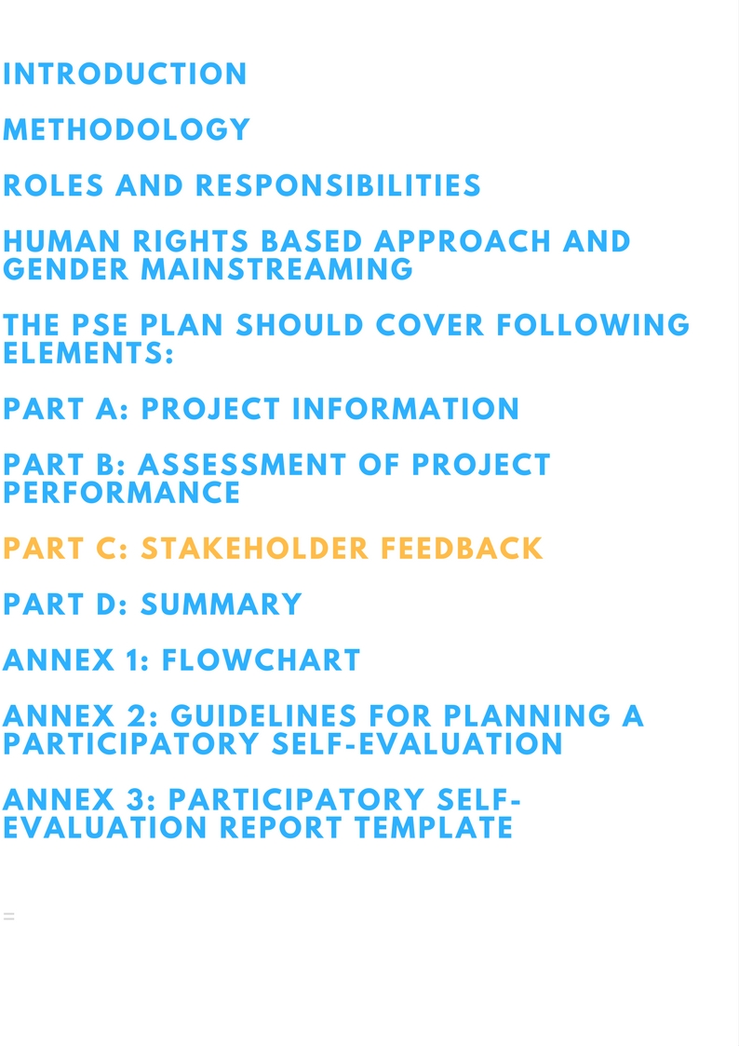

This section is to be filled out by projects stakeholders. Please note that confidentiality is strictly ensured in this process and the PSE Report will not attribute findings or assessments to individual respondents. Kindly start by reading the project managers responses in the previous section (B) Assessment of Project Performance.

## 1. RELEVANCE

*Relevance is defined as the extent to which the objectives of a project are continuously consistent with recipients’ needs, UNCTAD mandate and overarching strategies and policies. How would you assess the relevance of the project?*

Highly satisfactory

Satisfactory

Moderately satisfactory

Moderately unsatisfactory

Unsatisfactory

Highly unsatisfactory

**Click here to expand on your assessment**

## 2. EFFICIENCY

*Efficiency is defined as a measure of how resources/inputs (funds, expertise, time, etc.) are converted into outputs. How would you assess the efficiency of the project?*

Highly satisfactory

Satisfactory

Moderately satisfactory

Moderately unsatisfactory

Unsatisfactory

Highly unsatisfactory

**Click here to expand on your assessment**

## 3. EFFECTIVENESS

*Effectiveness is defined as the extent to which the project’s objectives and outcomes were achieved. How would you assess the effectiveness of the project?*

Highly satisfactory

Satisfactory

Moderately satisfactory

Moderately unsatisfactory

Unsatisfactory

Highly unsatisfactory

**Click here to expand on your assessment**

## 4. SUSTAINABILITY

*Sustainability is concerned with measuring whether the benefits of a project are likely to continue after its termination. Projects need to be environmentally as well as financially sustainable. How would you assess the sustainability of the project?*

Highly satisfactory

Satisfactory

Moderately satisfactory

Moderately unsatisfactory

Unsatisfactory

Highly unsatisfactory

**Click here to expand on your assessment**

## 5. IMPACT

*Impact refers to lasting changes—positive and negative, intended and unintended—arising from the intervention.. It may take years for these types of changes to become apparent. It is often difficult to attribute the observed changes to a particular intervention alone because other factors and actors may have contributed to the results as well. Thus, achieving the impact is generally beyond the direct control of the intervention.*

*Is there any evidence of the project’s interventions contributing or attributable to lasting impact?*

Yes Partially Mostly No N/A

**Click here to expand on your assessment**

## 6. GENDER AND HUMAN RIGHTS

*While gender equality is a human right, it is also a dimension of development in its own right. Gender and human rights refers to the extent to which the project’s achievements contributed to the improvement of gender equality and human rights. How would you assess this contribution by the project?*

Highly satisfactory

Satisfactory

Moderately satisfactory

Moderately unsatisfactory

Unsatisfactory

Highly unsatisfactory

**Click here to expand on your assessment**

## 7. PARTNERSHIP AND COOPERATION

*Partnerships and cooperation measure the level and quality of UNCTAD’s cooperation with diverse partners (e.g. donors, NGOs, Governments, other agencies etc.). How would you assess the partnerships and cooperation of the project?*

Highly satisfactory

Satisfactory

Moderately satisfactory

Moderately unsatisfactory

Unsatisfactory

Highly unsatisfactory

**Click here to expand on your assessment**

## 

## 8. LESSONS LEARNED

*Lessons learned are generalizations based on evaluation experiences with projects, programmes, or policies that abstract from the specific circumstances to broader situations. What lessons can be drawn from this project? Address specific strengths or weaknesses in preparation, design and implementation and /or specific factors that enabled success or impeded performance.*

**Click here to indicate your answer**

 This final section is to be filled in by the project manager when all stakeholder feedback is collected*.*

## 1. ASSESSMENT

*Please indicate here to what extent your assessment of the project correlates with the assessments of your stakeholders considering the evaluation criteria of (1) relevance, (2) efficiency, (3) effectiveness, (4) sustainability, (5) gender and human rights and (6) partnerships and cooperation.*

Full correlation

Strong correlation

Moderate correlation

Some correlation

No correlation at all

*Explain any potential discrepancies between your and your stakeholders’ assessments.*

**Click here to indicate your answer**

## 2. RECOMMENDATIONS

*Please indicate to what extent your recommendations correlate with the recommendations of your stakeholders considering (1) relevance, (2) efficiency, (3) effectiveness, (4) sustainability, (5) gender and human rights and (6) partnerships and cooperation.*

Full correlation

Strong correlation

Moderate correlation

Some correlation

No correlation at all

*List any additional recommendations from stakeholders.*

**Click here to indicate your answer**

## 3. LESSONS LEARNED

*Lessons learned are generalizations based on evaluation experiences with projects, programmes, or policies that abstract from the specific circumstances to broader situations. What lessons can be drawn from this project? Address specific strengths or weaknesses in preparation, design and implementation and /or specific factors that enabled success or impeded performance.*

*Please provide a summary of the lessons learned submitted through the stakeholder responses and address any potential discrepancies between those you identified.*

**Click here to indicate your answer**

## 4. OTHER RELEVANT INFORMATION

**Click here to add any other information relevant for this PSE Report**